**Git hub(Version Control System)**

Git is an open source version control system that allows collaboration. For instance, when developers create an app, they can make constant changes to the code, releasing new version up to and after the first official release.

Version control systems keep these revisions straight, storing the modifications in a central repository. This allows developers to easily collaborate, as they can download a new version of the software, make changes, and upload the newest revision. Every developer can see these new changes, download them, and contribute.

Git is a command line tool but the center around which all things involving Git is Hub, hence “GitHub.com” where developers store their projects and network with like minded people.

**Repository**

Repository (abbreviated as repo) is a location where all files of the particular projects are stored. Each project has its own repository and each collaborator can access the project with their unique Url.

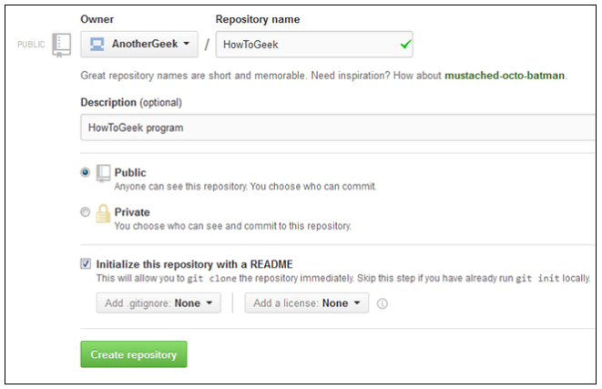

**Forking a repository**

“Forking” is when you create a new project based off of another project that already exists. This is an amazing feature that mostly encourages the further development of programs and other projects. If you find a project on GitHub that you’d like to contribute to, you can fork the repo, make the changes you’d like, and release the revised project as a new repo. If the original repository that you forked to create your new project gets updated, you can easily add those updates to your current fork.

**Pull Request**

You’ve forked a repository, made a great revision to the project, and want it to be recognized by the original developers—maybe even included in the official project/repository. You can do so by creating a pull request. The authors of the original repository can see your work, and then choose whether or not to accept it into the official project. Whenever you issue a pull request, GitHub provides a perfect medium for you and the main project’s maintainer to communicate.

**Social Networking**

The social networking aspect of GitHub is probably its most powerful feature, allowing projects to grow more than just about any of the other features offered. Each user on GitHub has their own profile that acts like a resume of sorts, showing your past work and contributions to other projects via pull requests.

**Github is not just for Developers**

All the above information about Github is ideal for programmers, however Github is not only for developers. If you have a team that is working on documents that are constantly changing, you can use github as your version control system.

**Hosting in Github**

Github only host Static websites on github pages where your can store files for your personal website which include html, css, and javascript files. It does not host dynamic applications that requires backend processing of data.

This means Github can only store project files for development purposes and enabling version control system. This establish a central point where developers can work together on a project rather that developing separately on their local machines.

*“I am still trying to figure out how to host an application from the github repository”*